Intelligent University Timetable Generator
A PROJECT REPORT

Submitted by

PONSURABHI V (2116241901077)
SWARNAMALA V (2116241901116)

in partial fulfillment for the award of the degree
of

BACHELOR OF ENGINEERING
in
COMPUTER SCIENCE AND ENGINEERING (CYBER SECURITY)



RAJALAKSHMI ENGINEERING COLLEGE
An Autonomous Institute

CHENNAI
NOVEMBER 2026

RAJALAKSHMI ENGINEERING COLLEGE
CHENNAI

BONAFIDE CERTIFICATE

Certified that this project report “INTELLIGENT UNIVERSITY TIMETABLE GENERATOR” is the bonafide work of “PONSURABHI V, SWARNAMALA V” who carried out the project work under my supervision.

SIGNATURE
Dr. Bhuvana S, Ph.D.,
ASSISTANT PROFESSOR(SG)
Department of Computer Science
and Engineering (Cyber Security)
Rajalakshmi Engineering College
Chennai – 602 105

Submitted to Project Viva-Voce Examination held on __________________

SIGNATURE OF THE INTERNAL EXAMINER

ABSTRACT

University timetable generation is a complex scheduling problem involving multiple interacting constraints such as faculty availability, classroom and laboratory availability, section-wise subject requirements, laboratory continuity, faculty workload, and conflict-free allocation of academic sessions. Manual timetable preparation becomes increasingly difficult as the number of departments, sections, subjects, rooms, faculty members, and practical sessions increases.
This project proposes an Intelligent Adaptive University Timetable Generator using Constraint Satisfaction Problem (CSP) techniques from Classical Artificial Intelligence. The timetable generation problem is modeled as a CSP in which class sessions represent variables, possible day-period-room combinations represent domains, and academic scheduling rules represent constraints. A Backtracking Search algorithm enhanced with constraint-based heuristics such as Minimum Remaining Values (MRV), Least Constraining Value (LCV), and Forward Checking is used to generate feasible timetables.
The system supports university-level scheduling across multiple departments and sections. It maintains constraints including conflict-free faculty and room allocation, section-wise scheduling, laboratory continuity, daily subject diversity, theory-period limits, laboratory restrictions, and faculty weekly workload limits. Laboratory classes are represented as two consecutive periods and are displayed as a single block in the timetable interface.
A major feature of the proposed system is adaptive rescheduling. When a faculty member reports an absence, the system identifies only the affected class sessions and attempts to handle the disruption through a qualified substitute or adaptive CSP-based rescheduling. The remaining timetable is preserved as far as possible. This avoids unnecessary regeneration of the entire timetable.
A web-based interface using Flask provides role-based access for administrators, faculty, and students. Administrators can generate and manage timetables and approve absence requests, faculty members can report absences, and students can view their updated timetables. The system therefore demonstrates the application of Classical AI search and constraint reasoning to a practical university scheduling problem.
Keywords: Artificial Intelligence, Constraint Satisfaction Problem, Backtracking, Adaptive Scheduling, University Timetable, Faculty Scheduling, Conflict Resolution.

ACKNOWLEDGEMENT
First and foremost, we thank Almighty God for enabling us to complete this project successfully. We express our sincere gratitude to our Chairman, Mr. S. Meganathan, B.E., F.I.E., for his dedicated efforts in providing quality education at this esteemed institution. We are deeply grateful to our beloved Chairperson, Dr. Thangam Meganathan, Ph.D., for her constant motivation and encouragement, which inspired us throughout the completion of this project. We also thank our Vice Chairman, Mr. Abhay Shankar Meganathan, B.E., M.S., for providing the necessary infrastructure and facilities.
We express our sincere gratitude to our College Principal, Dr. S. N. Murugesan, M.E., Ph.D., and Dr. P. Tamilselvi, Ph.D., Professor and Head, Department of Computer Science and Engineering (Cyber Security), for their support and encouragement.
We are especially thankful to our project guide, Dr. Bhuvana S., Ph.D., Assistant Professor (SG), for her valuable guidance, continuous encouragement, and support throughout the project. Finally, we thank our parents and friends for their direct and indirect contributions, encouragement, and support in the successful completion of this project.
PONSURABHI V (2116241901077)
SWARNAMALA V (2116241901116)
TABLE OF CONTENTS
CHAPTER NO. | TITLE | PAGE NO.
 | ABSTRACT | iii
 | LIST OF TABLES | vii
 | LIST OF FIGURES | viii
1 | INTRODUCTION | 1
 | 1.1 BACKGROUND | 1
 | 1.2 PROBLEM STATEMENT | 1
 | 1.3 OBJECTIVES | 2
 | 1.4 SCOPE | 2
 | 1.5 SECURITY REQUIREMENTS/  SECURITY CONSIDERATIONS | 2
 | 1.6 SDG ALIGNMENT | 3
 | 1.6.1. SDG 4 - QUALITY EDUCATION | 3
 | 1.6.2. SDG 9 – INDUSTRY, INNOVATION AND INFRASTRUCTURE | 3
2 | LITERATURE REVIEW | 4
 | 2.1 EXISTING SYSTEM WITH  SECURITY APPROACHES | 4
 | 2.2 RESEARCH GAPS | 5
 | 2.3 PROPOSED SYSTEM | 5
 | 2.3.1 OVERVIEW OF THE  PROPOSED SYSTEM | 6
 | 2.3.2 OBJECTIVES OF THE  PROPOSED SYSTEM | 7
 | 2.3.3 ADVANTAGES OF  PROPOSED SYSTEM | 7
3 | SYSTEM DESIGN | 8
 | 3.1 SYSTEM ARCHITECTURE | 8
 | 3.1.1 SOFTWARE  REQUIREMENTS | 8
 | 3.1.2 HARDWARE  REQUIREMENTS | 8
 | 3.2 MODULE DESIGN | 9
 | 3.2.1. UNIVERSITY DATA  MANAGEMENT MODULE | 9
 | 3.2.2. CSP FORMULATION  MODULE | 9
 | 3.2.3. CONSTRAINT VALIDATION  MODULE | 10
 | 3.2.4. OPTIMIZED SEARCH  MODULE | 11
 | 3.2.5. ADAPTIVE TIMETABLE  RESCHEDULING MODULE | 12
 | 3.3 DATA FLOW/UML DIAGRAMS | 13
 | 3.4 THREAT MODEL AND ATTACK SURFACE | 15
 | 3.5 SECURITY CONTROLS | 15
4 | SYSTEM DESCRIPTION | 17
 | 4.1 DATA COLLECTION | 17
 | 4.2 DATA PREPROCESSING | 17
 | 4.2.1 ALGORITHMS /  METHODOLOGY | 18
 | 4.2.2 RESULTS AND  DISCUSSION | 20
5 | 5.1 CONCLUSION | 24
 | 5.2 FUTURE ENHANCEMENTS | 24
 | 5.3 REFERENCES | 25
 | APPENDIX | 26

LIST OF TABLES

TABLE NO. | TITLE | PAGE NO.
1.6.2 | SDG ALIGNMENT | 3
3.1.1 | SOFTWARE REQUIREMENTS | 8
3.1.2 | HARDWARE REQUIREMENTS | 8
3.4 | POSSIBLE THREATS | 15
4.2.2 | VALIDATION CHECK | 21

LIST OF FIGURES

FIGURE | TITLE | PAGE NO.
2.3.1 | WORKFLOW OF THE SYSTEM | 6
3.2.1 | UNIVERSITY DATA MANAGEMENT | 9
3.2.2 | CSP FORMULATION | 10
3.3.3 | CONSTRAINT VALIDATION | 11
3.2.4 | OPTIMIZED SEARCH | 12
3.2.5 | ADAPTIVE TIMETABLE RESCHEDULING | 12
3.3.1 | SYSTEM ARCHITECTURE | 13
3.3.2 | USE CASE DIAGRAM | 13
3.3.3 | ACTIVITY DIAGRAM | 14
3.3.4 | SEQUENCE DIAGRAM | 14
4.2.1.1 | BACKTRACKING SEARCH | 19
4.2.1.2 | ADAPTIVE RESCHEDULING ALGORITHM | 20
4.2.2.1 | ALGORITHM COMPARISON BAR GRAPH | 22
4.2.2.2 | ALGORITHM COMPARISON STATISTICS | 23

CHAPTER 1
INTRODUCTION
1.1 BACKGROUND
University timetable scheduling is a combinatorial problem in which a large number of academic activities must be assigned to limited time and physical resources while satisfying several constraints.
A university timetable must coordinate:
- Departments, Sections
- Subjects, Faculty members
- Classrooms, Laboratories
- Theory sessions, Practical sessions
- Working days, Periods
- Faculty workload
- Section availability
A small change in one scheduling component can create conflicts in other parts of the timetable. For example, when a faculty member becomes unavailable, simply moving the affected class may result in a room conflict, faculty conflict, or section conflict.
Traditional manual scheduling requires considerable time and repeated checking. It also becomes difficult to adapt an already generated timetable to unexpected changes.
Artificial Intelligence provides techniques for solving such problems through search, constraint reasoning, and automated decision-making.
This project applies the Constraint Satisfaction Problem (CSP) model to university timetable generation. Instead of manually assigning classes, the system represents the timetable as a collection of variables, domains, and constraints and searches for a feasible assignment. The project further extends conventional timetable generation with adaptive rescheduling, allowing the system to respond to faculty absence without unnecessarily rebuilding the complete timetable.

1.2 PROBLEM STATEMENT
Manual university timetable generation is challenging due to constraints involving faculty availability, section and classroom conflicts, laboratory scheduling, subject requirements, and faculty workload. Moreover, faculty absences can disrupt existing schedules, while regenerating the entire timetable causes unnecessary changes. Therefore, an intelligent system is needed to generate conflict-free timetables and adaptively reschedule only the affected classes while preserving the remaining schedule.
1.3 OBJECTIVES
- Generate conflict-free timetables using Backtracking Search, MRV, LCV, and Forward Checking.
- Satisfy faculty, classroom, section, laboratory, and workload constraints.
- Adaptively reschedule affected classes during faculty absences.
- Preserve unaffected assignments and provide updated timetables through role-based interfaces.
1.4 SCOPE
The project focuses on automated university timetable generation using CSP and Classical AI techniques. It considers faculty availability, classroom allocation, section requirements, laboratory scheduling, and workload constraints. The system also supports adaptive rescheduling during faculty absences by changing only affected classes while preserving the remaining timetable. Administrators can manage timetables, faculty can report absences, and students can view updated schedules through role-based interfaces.
1.5 SECURITY REQUIREMENTS / SECURITY CONSIDERATIONS
Although timetable generation is primarily an AI scheduling problem, the system handles user profiles and administrative actions.
- Authentication
Users should access the system through role-specific login credentials.
- Authorization
Different roles must have different privileges.
- Data integrity: Timetable assignments should not be modified without authorized operations.
- Database security: SQLite is used for local persistence during the prototype implementation. Database access should be controlled through the application layer.
- Input validation: Faculty absence requests should be validated before being processed.
- Session protection: User sessions should not allow unauthorized access to administrative functionality.
- Auditability: Leave and adaptive scheduling operations should provide information about the affected class and resulting schedule.
1.6 SDG ALIGNMENT
1.6.1. SDG 4 – Quality Education
- Relevant Target: Ensure inclusive and equitable quality education and promote lifelong learning opportunities for all.
- Project contribution: The system improves academic resource management by automating timetable generation and reducing scheduling conflicts. A reliable timetable can help students and faculty access their academic schedules consistently.
1.6.2. SDG 9 – Industry, Innovation and Infrastructure
- The project applies Artificial Intelligence and automated constraint reasoning to improve institutional scheduling infrastructure.
SDG | Goal | Project Contribution
SDG 4 | Quality Education | Efficient academic scheduling
SDG 9 | Industry, Innovation and Infrastructure | AI-based automated scheduling
SDG 16 | Peace, Justice and Strong Institutions | Structured and transparent administrative scheduling
Table 1.6.2. SDG Alignment

CHAPTER 2
LITERATURE REVIEW
University timetabling is a constraint-based scheduling problem that involves allocating courses, faculty members, classrooms, and time slots while satisfying academic and resource requirements. Zhang and Lau [1] presented a constraint satisfaction programming approach for constructing university timetables. Their work provides a foundation for modelling scheduling requirements as constraints and finding feasible timetable assignments. Abdelraouf et al. [2] explored a visual entity-relationship model for constraint-based university timetabling, providing a structured way to represent the entities and relationships involved in scheduling. Ceschia et al. [3] discussed educational timetabling problems, benchmarks, and state-of-the-art results, highlighting the complexity of timetabling problems and the importance of systematic evaluation. Cheng et al. [4] investigated the use of constraint logic programming for university timetabling, demonstrating the relevance of logic-based constraint methods for scheduling. Burke et al. [5] examined decomposition, reformulation, and diving techniques for university course timetabling to improve the handling of complex scheduling problems. Based on these studies, the proposed system uses Constraint Satisfaction Problem (CSP) formulation and Backtracking Search, combined with Minimum Remaining Values (MRV), Least Constraining Value (LCV), and Forward Checking, to generate feasible university timetables. It further incorporates adaptive rescheduling to handle faculty absences by attempting substitution or rescheduling affected classes while preserving unaffected timetable assignments.

2.1 EXISTING SYSTEM WITH SECURITY APPROACHES
Traditional university timetable systems generally rely on manually prepared schedules or rule-based scheduling mechanisms. Manual scheduling requires academic administrators to repeatedly verify faculty availability, classroom availability, section conflicts, laboratory requirements, and weekly subject-hour requirements. These processes are time-consuming and may lead to scheduling errors when multiple departments and resources are involved.
Some automated timetable systems employ heuristic algorithms and mathematical optimization techniques to improve scheduling efficiency. Zhang and Lau [1] proposed a Constraint Satisfaction Programming (CSP) approach for constructing university timetables by representing scheduling activities using variables, domains, and constraints. Their approach used ILOG Scheduler and ILOG Solver to generate feasible timetables while satisfying resource-related constraints. However, adapting an existing timetable to sudden changes, such as faculty absences, remains an important practical requirement. The proposed system builds upon the CSP approach by incorporating adaptive timetable rescheduling, which identifies affected classes and attempts to modify only the necessary assignments while preserving unaffected portions of the timetable.

2.2 RESEARCH GAPS
From the existing approach, the following gaps are identified:
- Limited adaptability in a timetable generated initially may require substantial modification when faculty availability changes.
- Many scheduling approaches focus primarily on generating an initial feasible timetable rather than preserving the existing timetable during disruptions.
- Traditional timetable generation may not provide integrated faculty absence reporting and student-specific timetable updates.
- Laboratory continuity, room availability, faculty workload, and section constraints need to be handled simultaneously.
- When one class is affected, changing unrelated classes is undesirable.

2.3 PROPOSED SYSTEM
- The proposed system automatically generates university timetables using Constraint Satisfaction Problem (CSP) formulation and Backtracking Search to assign classes to suitable days, periods, and classrooms.
- It uses Minimum Remaining Values (MRV), Least Constraining Value (LCV), and Forward Checking to improve the search process and identify scheduling conflicts efficiently.
- The system ensures that faculty availability, classroom allocation, section requirements, laboratory scheduling, and weekly workload constraints are satisfied.
- It supports adaptive rescheduling during faculty absences by identifying affected classes, assigning suitable substitute faculty when available, or using CSP-based rescheduling when necessary.
- The system preserves unaffected timetable assignments, stores scheduling information in an SQLite database, and provides role-based interfaces for administrators, faculty members, and students to manage and view updated timetables.
2.3.1 OVERVIEW OF THE PROPOSED SYSTEM
The system follows this workflow:
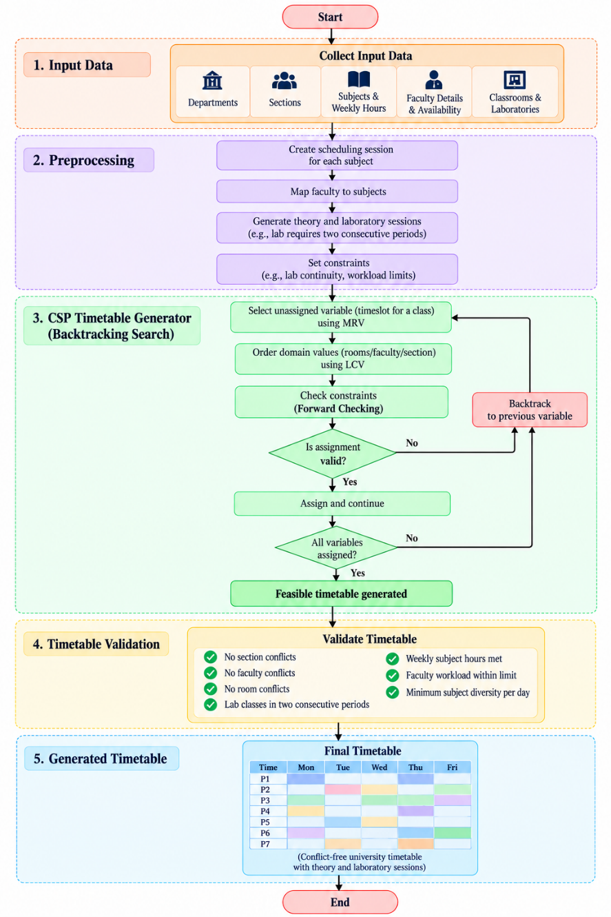
Figure 2.3.1 Workflow of the system
The flowchart illustrates the initial timetable generation process, from collecting input data and preprocessing scheduling requirements to generating a feasible timetable using CSP, Backtracking Search, MRV, LCV, and Forward Checking. The timetable is validated against scheduling constraints before the final conflict-free timetable is generated.

2.3.2 OBJECTIVES OF THE PROPOSED SYSTEM
- Automate conflict-free timetable generation using CSP and Classical AI techniques.
- Optimize scheduling using heuristics while satisfying faculty, classroom, laboratory, and workload constraints.
- Support adaptive rescheduling with minimal changes and role-based timetable access.
2.3.3 ADVANTAGES OF PROPOSED SYSTEM
The proposed system automates timetable generation using constraint-based reasoning to reduce manual effort and prevent faculty, classroom, and section conflicts. It supports consecutive two-period laboratory sessions and role-based access for administrators, faculty, and students. Its adaptive scheduling mechanism handles faculty absences by rescheduling only affected classes, minimizing unnecessary changes to the existing timetable.

CHAPTER 3
SYSTEM DESIGN
3.1 SYSTEM ARCHITECTURE
3.1.1. Software Requirements:
S.No. | Software Requirement | Specification
1 | Operating System | Windows / Linux
2 | Programming Language | Python 3.x
3 | Framework | Flask
4 | Database | SQLite
5 | Frontend | HTML, CSS, JavaScript
6 | IDE | Visual Studio Code
7 | Web Browser | Chrome / Edge / Firefox
8 | Visualization Tool | Matplotlib
Table 3.1.1. Software Requirements

3.1.2. Hardware Requirements:
S.No. | Requirement | Specification
1 | Processor | Intel Core i3 or equivalent
2 | RAM | 4 GB or above
3 | Storage | 10 GB free space
4 | Display | 1366 × 768 or above
5 | Network | Wi-Fi / Ethernet
Table 3.1.2. Hardware Requirements

The system consists of four main layers. The Presentation Layer uses Flask, HTML, CSS, and JavaScript to provide the user interface. The Application Layer handles user management, timetable generation, leave management, and adaptive scheduling. The AI Layer applies CSP, Backtracking Search, MRV, LCV, Forward Checking, and constraint validation. Finally, the Data Layer uses an SQLite database to store and manage system information.

3.2 MODULE DESIGN
3.2.1. University Data Management Module
This module manages all essential academic information required for timetable generation. It maintains details of departments, sections, subjects, faculty members, classrooms, laboratories, and course offerings. The collected data includes subject requirements, faculty qualifications, room capacities, and available resources. This information acts as the foundation for the CSP solver and ensures that timetable assignments are based on valid academic data.

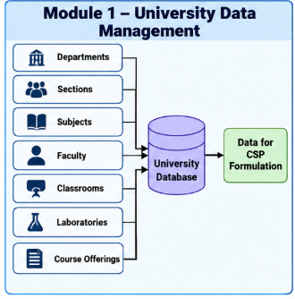
Figure 3.2.1 University Data Management
In Figure 3.2.1, university details, including departments, subjects, faculty, classrooms, and laboratories are stored in database.

3.2.2. CSP Formulation Module
This module represents university timetable scheduling as a Constraint Satisfaction Problem (CSP). Each class session is treated as a variable, while its possible day, period, and room combinations form its domain. The module defines hard constraints, including faculty availability, section and room conflicts, laboratory continuity, weekly subject requirements, and faculty workload limits. These variables, domains, and constraints form the input to the timetable search algorithm.
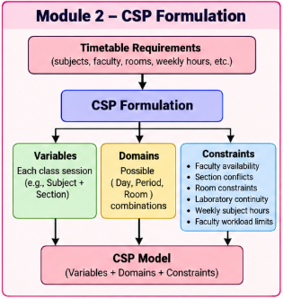
Figure 3.2.2 CSP Formulation
Figure 3.2.2 represents the timetable scheduling problem as a Constraint Satisfaction Problem (CSP) by defining variables, domains, and constraints based on university requirements.

3.2.3. Constraint Validation Module
This module verifies whether timetable assignments satisfy the defined academic and scheduling rules. It checks that faculty members, student sections, and classrooms are not assigned to multiple classes simultaneously. It also validates laboratory duration, room suitability, subject-wise weekly requirements, and faculty workload limits. Invalid assignments are rejected during the search process, helping the system produce a feasible and conflict-free timetable.
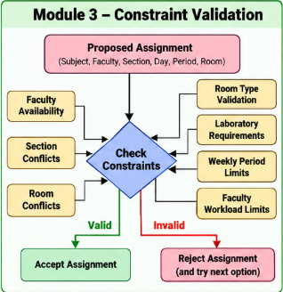
Figure 3.2.3 Constraint Validation

Figure 3.2.3 validates proposed timetable assignments by checking faculty availability, section and room conflicts, laboratory requirements, weekly period limits, and faculty workload.

3.2.4. Optimized Search Module
This module generates timetable assignments using Backtracking Search combined with classical AI heuristics. The Minimum Remaining Values (MRV) heuristic selects the most constrained variable first, while Least Constraining Value (LCV) prioritizes assignments that leave more options for other classes. Forward Checking detects domain conflicts early by removing incompatible future assignments. When a conflict occurs, Backtracking Search revises earlier assignments until a feasible timetable is found or the search determines that the current configuration cannot be completed.
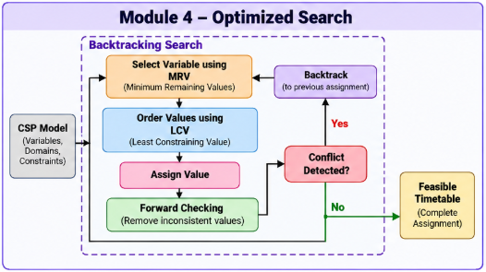
Figure 3.2.4 Optimized Search
Figure 3.2.4 uses Backtracking Search, MRV, LCV, and Forward Checking to explore possible assignments, resolve conflicts, and generate a feasible timetable.
3.2.5. Adaptive Timetable Rescheduling Module
This module handles timetable disruptions caused by faculty absences. When a leave request is processed, the system identifies the affected classes and checks whether qualified substitute faculty members are available. If a suitable substitute is found, the affected class can be reassigned accordingly. Otherwise, the adaptive CSP mechanism reschedules the affected class while maintaining all scheduling constraints. The system preserves unaffected timetable assignments wherever possible, reducing unnecessary changes and maintaining timetable stability.
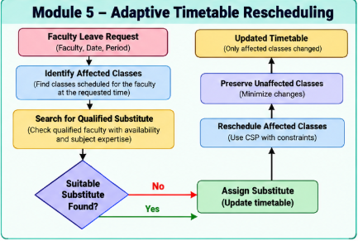
Figure 3.2.5 Adaptive Timetable Rescheduling

Figure 3.2.5 illustrates handling faculty absences by identifying affected classes, searching for suitable substitutes, and rescheduling when necessary while preserving unaffected assignments.

3.3 DATA FLOW / UML DIAGRAMS
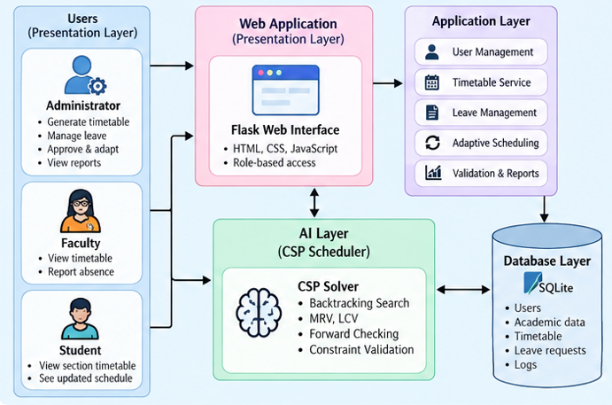
Figure 3.3.1 System Architecture
Figure 3.3.1 illustrates the overall system architecture, showing the interaction between users, the Flask web application, application modules, the CSP scheduler, and the SQLite database.

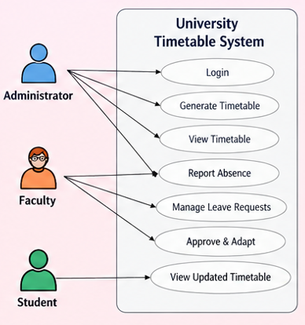
Figure 3.3.2 Use Case Diagram
Figure 3.3.2 represents the interactions of the three user roles—Administrator, Faculty, and Student—with the university timetable system and its functionalities.

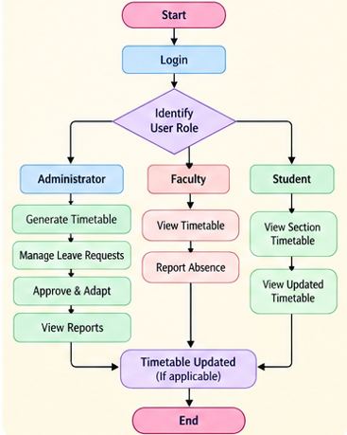
Figure 3.3.3 Activity Diagram
Figure 3.3.3 shows the workflow of the system, from login and role identification to role-specific activities and timetable updates.

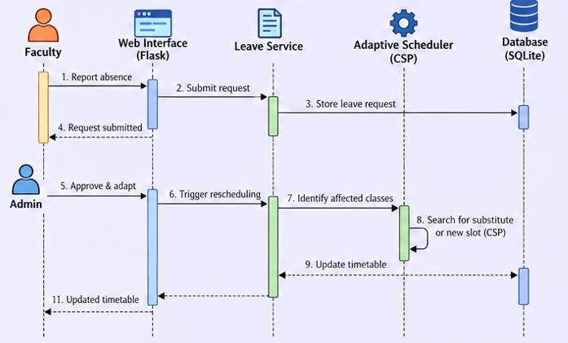
Figure 3.3.4 Sequence Diagram
Figure 3.3.4 illustrates the sequence of interactions between faculty, the web interface, leave service, adaptive scheduler, and database during faculty absence reporting and timetable rescheduling.

3.4 THREAT MODEL AND ATTACK SURFACE
The attack surface of the proposed university timetable system includes the login interface, role-based pages, leave request form, database, administrative timetable operations, and session management. The login interface may be exposed to unauthorized access attempts, while role-based pages require proper access controls to prevent users from accessing functions beyond their permissions. The leave request form must validate user inputs to prevent invalid or malicious submissions. The database requires protection against unauthorized access and data manipulation. Administrative timetable operations must be secured to prevent unauthorized timetable modifications, and session management must protect user sessions against misuse and unauthorized access.

Threat | Description
Unauthorized access | User attempts to access another role
Privilege escalation | Student attempts admin operation
Input manipulation | Malicious leave request values
Database manipulation | Unauthorized timetable modification
Session abuse | Unauthorized use of an active session
Data exposure | Unauthorized viewing of faculty/student information

Table 3.4 Possible Threats

3.5 SECURITY CONTROLS
The proposed prototype implements several security controls to protect the university timetable system. Role-based access control and separation of user roles ensure that administrators, faculty members, and students can access their respective functionalities. Input validation helps prevent invalid data submissions, while session-based access manages user interactions with the application. Administrative operations are restricted to authorized users, and database-backed persistence ensures that university data and timetable information are stored systematically. Controlled timetable modification helps prevent unauthorized changes to scheduling assignments. For future production deployment, additional security measures such as stronger authentication, password hashing, HTTPS, Cross-Site Request Forgery (CSRF) protection, audit logging, and enhanced database access controls should be implemented.

CHAPTER 4
SYSTEM DESCRIPTION
4.1 DATA COLLECTION
The timetable system uses structured university academic information to generate feasible timetables. The planning dataset covers six departments: IT, CSBS, CSE, CSD, AIML, and AIDS, with two sections per department. The collected input information includes subject names, subject codes, weekly theory requirements, weekly practical requirements, faculty assignments, section details, classrooms, and laboratories.
The planning data also includes common subjects such as Computer Networks, Web Programming, Deep Learning, and Soft Skills-II, which are considered during timetable generation to ensure appropriate allocation of academic sessions and resources.

4.2 DATA PREPROCESSING
- Step 1 – Department Creation
Six departments, namely IT, CSBS, CSE, CSD, AIML, and AIDS, are created in the system to organize academic information and support department-wise timetable generation.
- Step 2 – Section Creation
Each department is divided into two sections, Section A and Section B. This allows the system to generate separate timetables for each section and avoid scheduling conflicts.
- Step 3 – Subject Creation
Each subject is represented using a unique Subject ID, subject name, weekly hours, and session type, such as theory or practical. The subject is also associated with its corresponding department and section to ensure accurate scheduling.
- Step 4 – Faculty Mapping
Subjects are mapped to the respective faculty members based on their teaching assignments. This mapping helps the system check faculty availability and prevent overlapping class schedules.
- Step 5 – Resource Mapping
Classrooms and laboratories are mapped to the relevant departments and academic activities. The system uses this information to allocate suitable resources while avoiding room conflicts.
- Step 6 – Session Generation
The required weekly hours of each subject are converted into individual schedulable class sessions. These sessions serve as the variables for the CSP-based timetable generation process.
- Step 7 – Laboratory Handling
Each laboratory class is represented as a block of two consecutive periods. This ensures that laboratory sessions remain continuous and are scheduled without interruption.

4.2.1 ALGORITHMS / METHODOLOGY
- CONSTRAINT SATISFACTION PROBLEM
A Constraint Satisfaction Problem (CSP) consists of variables, domains, and constraints. In the proposed system, each required class session is represented as a variable, such as CSE-A – Database Management Systems – Theory Session 1. The domain of each variable contains possible combinations of day, period, and room assignments. The solver evaluates these assignments and eliminates those that violate the scheduling requirements.
The system considers several hard constraints to ensure timetable validity. A section cannot have two classes scheduled simultaneously, a faculty member cannot teach multiple classes at the same time, and a classroom cannot be occupied by more than one class simultaneously. The required weekly subject periods must be fulfilled, and each laboratory session must occupy two consecutive periods without crossing the lunch interval. The same theory subject can be scheduled at most twice per day, while the same laboratory subject can have at most one laboratory block per day. Additionally, each section must have at least three distinct subjects on a working day, and faculty members must not exceed the specified maximum weekly workload.
Along with hard constraints, the system considers soft constraints and scheduling preferences to improve timetable quality. These include distributing faculty workload across the week, spreading section workload across different days, avoiding undesirable consecutive theory sessions, and preserving existing timetable assignments during adaptive rescheduling. These preferences help the system generate balanced timetables while minimizing unnecessary changes to the existing schedule.

- BACKTRACKING SEARCH
Backtracking Search generates a feasible timetable by assigning values to variables incrementally and checking whether each assignment satisfies the scheduling constraints. As shown in Figure 4.1, the solver uses Minimum Remaining Values (MRV) to select the most constrained unassigned variable and Least Constraining Value (LCV) to prioritize values that restrict other variables the least. After assigning a value, Forward Checking examines the remaining domains to identify potential conflicts early. If an invalid assignment occurs, the solver backtracks and tries another value. This process continues until all variables are successfully assigned, resulting in a feasible timetable.

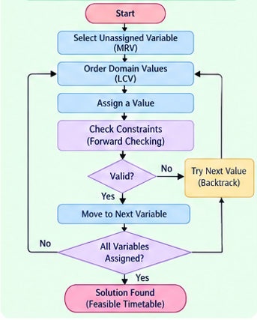
Figure 4.2.1.1 Backtracking search
Figure 4.2.1.1 illustrates the backtracking search process used to generate a feasible timetable.

- ADAPTIVE RESCHEDULING ALGORITHM
The system identifies the affected classes and checks whether a qualified substitute faculty member is available. If a suitable substitute is found, the system assigns the substitute to the same time slot and updates the timetable. Otherwise, it uses CSP-based Backtracking Search to find an alternative time slot, validates the scheduling constraints, and reschedules the affected class. Finally, the updated timetable is saved.

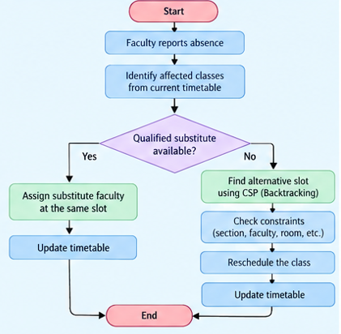
Figure 4.2.1.2 Adaptive Rescheduling Algorithm
Figure 4.2.1.2 represents the adaptive rescheduling workflow, which handles faculty absences through substitution or CSP-based rescheduling while maintaining timetable validity.

4.2.2 RESULTS AND DISCUSSION
The system successfully generates a university timetable while satisfying the implemented scheduling constraints. The generated timetable covers five working days, with seven periods per day, and supports both theory sessions and two-period laboratory sessions. It accommodates multiple departments and sections while ensuring appropriate faculty and classroom allocation. The system validates the assignments against the defined constraints to produce a feasible timetable that meets the university's scheduling requirements.
The implemented validation checks include:
Constraint | Result
Five working days | PASS
Seven periods/day | PASS
Section conflicts | PASS
Faculty conflicts | PASS
Room conflicts | PASS
Weekly subject requirements | PASS
Daily subject diversity | PASS
Theory ≤ 2/day for same subject | PASS
Different labs on same day | PASS
Same lab subject not repeated same day | PASS
Lab continuity | PASS
Lab does not cross lunch | PASS
Faculty weekly workload ≤16 | PASS
Section workload distribution | PASS

Table 4.2.2 Validation Check
In the adaptive timetable rescheduling scenario, a faculty member reports an absence that affects a scheduled class. Initially, the class is assigned to its original timetable slot. After the administrator approves the absence, the system identifies the affected class and searches for a feasible alternative. The affected class is then assigned to a new valid time slot, while the remaining timetable assignments are preserved unchanged. This demonstrates the system's ability to handle faculty absences while maintaining scheduling validity and minimizing changes to the existing timetable.
The Admin Dashboard allows the administrator to generate and view timetables, filter scheduling information, and monitor system statistics. It also provides facilities to manage faculty leave requests, approve or reject reported absences, and trigger adaptive scheduling to ensure minimal disruption to the existing timetable.
The Faculty Dashboard enables faculty members to view their assigned timetables and report absences when they are unable to attend scheduled classes. These requests can then be processed by the administrator for substitution or adaptive rescheduling.

The Student Dashboard allows students to view their respective section timetables and access updated class timings. It also enables them to identify rescheduled classes, helping them stay informed about timetable changes resulting from faculty absences.
To evaluate the performance of the proposed CSP-based timetable generation system, four search strategies were compared: Basic Backtracking, Backtracking with Minimum Remaining Values (MRV), MRV with Least Constraining Value (LCV), and MRV with LCV and Forward Checking. The comparison considers execution time, number of search nodes, backtracks, and constraint checks. These metrics help analyse the computational overhead and search behaviour of each strategy and determine how the optimization techniques affect timetable generation performance. The results are presented in the following graphs and statistical output.
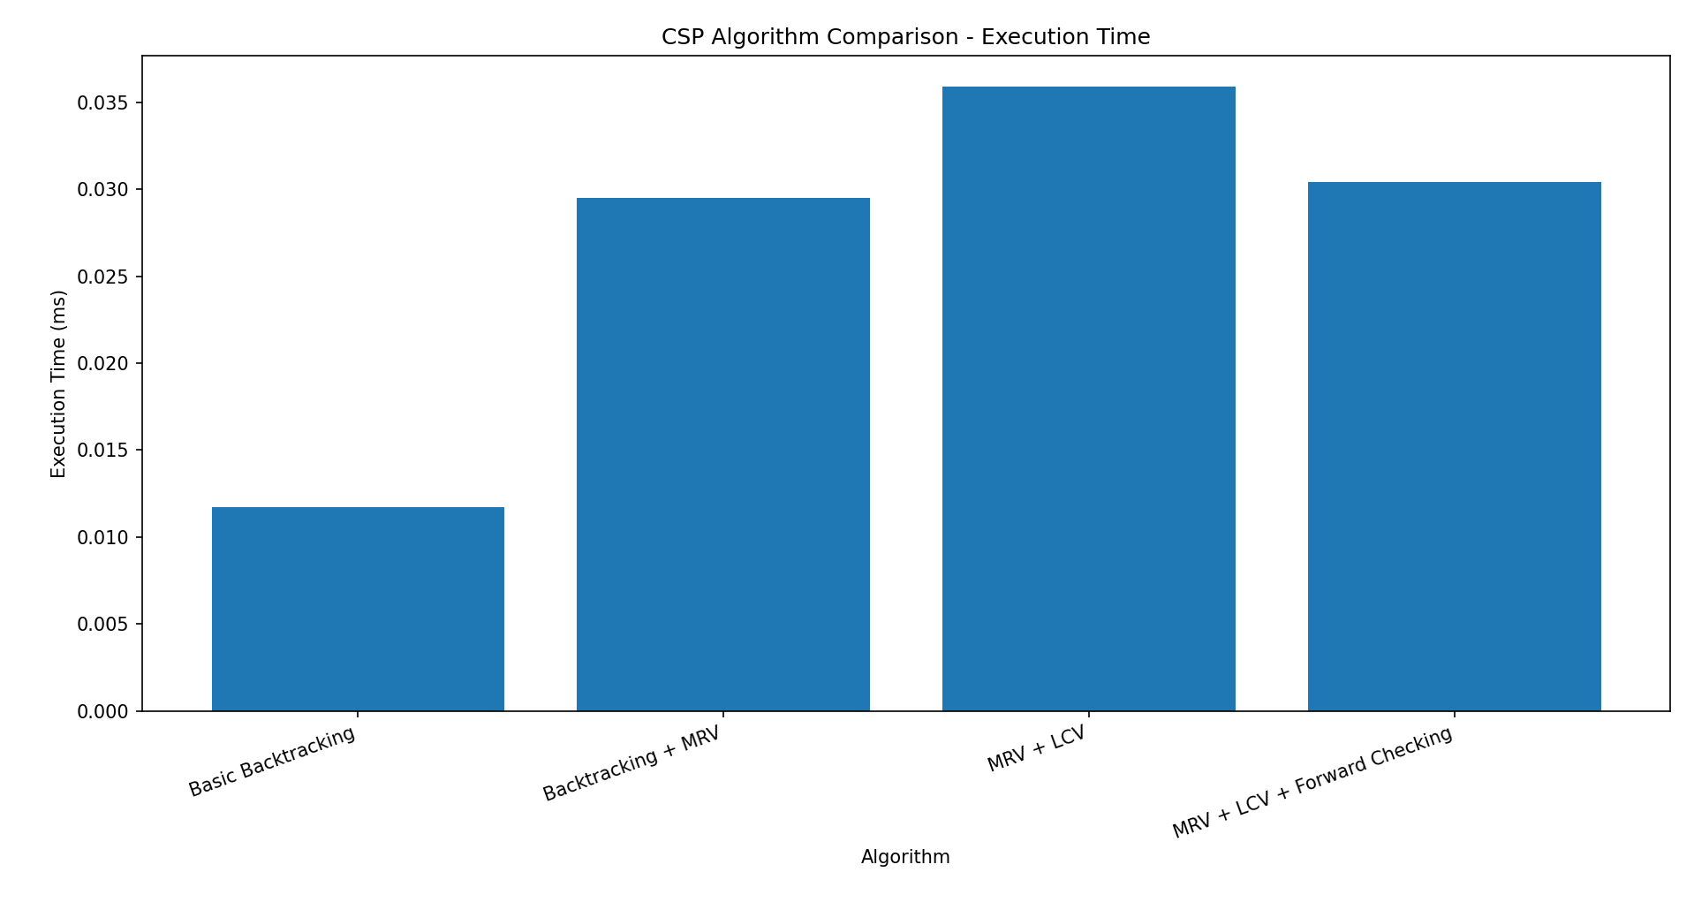
Figure 4.2.2.1 Comparison bar graph
The bar graph in Figure 4.2.2.1 compares the execution time of four CSP algorithms: Basic Backtracking, Backtracking with MRV, MRV with LCV, and MRV with LCV and Forward Checking. Basic Backtracking achieved the lowest execution time of 0.0117 ms, followed by Backtracking with MRV at 0.0295 ms, MRV with LCV at 0.0359 ms, and MRV with LCV and Forward Checking at 0.0304 ms. In this experiment, Basic Backtracking was the fastest, while the additional optimization techniques introduced overhead for the tested problem.
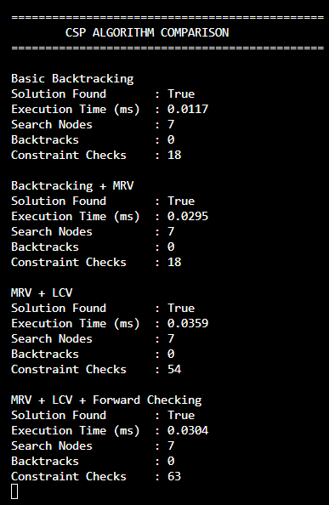
Figure 4.2.2.2 Comparison Statistics
The output in figure 4.2.2.2 displays the performance metrics of the four CSP algorithms. All algorithms successfully found a solution, explored 7 search nodes, and recorded 0 backtracks. Basic Backtracking and Backtracking with MRV each performed 18 constraint checks, while MRV with LCV performed 54 and MRV with LCV and Forward Checking performed 63 constraint checks. These results indicate that, for this particular test case, the optimization techniques increased the number of constraint checks without reducing the search nodes or backtracks. Therefore, their effectiveness should be evaluated using more complex scheduling problems as well.

CHAPTER 5
5.1 CONCLUSION
The Intelligent Adaptive University Timetable Generator Using Constraint Satisfaction Problem successfully demonstrates the application of Classical Artificial Intelligence techniques to university timetable scheduling. The timetable generation problem is modeled as a Constraint Satisfaction Problem consisting of variables, domains, and constraints. Backtracking Search is used to explore possible assignments, while MRV, LCV, and Forward Checking improve the search process. The system handles multiple departments, sections, subjects, faculty members, classrooms, and laboratories while enforcing important scheduling constraints such as faculty conflict avoidance, section conflict avoidance, room availability, weekly subject requirements, laboratory continuity, daily subject diversity, and faculty workload. The major contribution of the project is its adaptive rescheduling capability. Instead of regenerating the entire timetable when a faculty absence affects a class, the system identifies the affected assignment and attempts to preserve the remaining schedule. Qualified substitute faculty can be considered first, and when substitution is not possible, the adaptive CSP mechanism searches for a valid alternative slot. The web interface further provides separate interactions for administrators, faculty members, and students. This allows the scheduling system to move beyond a static timetable generator toward an interactive academic scheduling system. The project demonstrates that Classical AI techniques such as CSP, Backtracking, heuristic variable selection, and constraint propagation can be effectively applied to real-world scheduling problems.

5.2 FUTURE ENHANCEMENTS
- Implement secure password-based authentication using password hashing and multi-factor authentication.
- Migrate from SQLite to PostgreSQL or another production-grade database to support larger datasets.
- Integrate the system with university calendars to synchronize academic schedules and events.
- Implement automatic notifications to inform students and faculty about timetable changes and rescheduled classes.
- Introduce advanced optimization techniques considering faculty preferences, room preferences, student free periods, and minimization of consecutive classes.
- Extend the system to support timetable scheduling across multiple campuses and buildings.
- Maintain detailed audit logs to track timetable modifications, actions performed, and responsible users.

5.3 REFERENCES

[1] Zhang, L., & Lau, S. K. (2005). Constructing university timetable using constraint satisfaction programming approach. Proceedings of the International Conference on Computational Intelligence for Modelling, Control and Automation, 2, 55–60. https://doi.org/10.1109/CIMCA.2005.1631445

[2] Abdelraouf, I., Abdennadher, S., & Gervet, C. (2011). A visual entity-relationship model for constraint-based university timetabling. arXiv. https://arxiv.org/abs/1109.6112

[3] Ceschia, M., Di Gaspero, T., Schaerf, A., & others. (2022). Educational timetabling: Problems, benchmarks and state-of-the-art results. Annals of Operations Research.

[4] Cheng, C., Kang, L., Leung, N., & White, G. M. (2005). Investigations of a constraint logic programming approach to university timetabling. Lecture Notes in Computer Science.

[5] Burke, E. K., Mareček, J., Parkes, A. J., & Rudová, H. (2009). Decomposition, reformulation, and diving in university course timetabling. Operations Research Proceedings. https://arxiv.org/abs/0903.1095

APPENDIX

APPENDIX A – TECHNOLOGY STACK

Category | Technology
Programming Language | Python
AI Technique | Constraint Satisfaction Problem
Search | Backtracking
Heuristics | MRV, LCV
Constraint Propagation | Forward Checking
Backend | Flask
Frontend | HTML, CSS, JavaScript
Database | SQLite
Development Environment | VS Code
Testing | Pytest

Table A1

APPENDIX B – DEMONSTRATION ACCOUNTS
Admin: admin@university.edu
Faculty: facultyf001@university.edu
Student: student.it.a@university.edu

APPENDIX C – PROJECT STRUCTURE

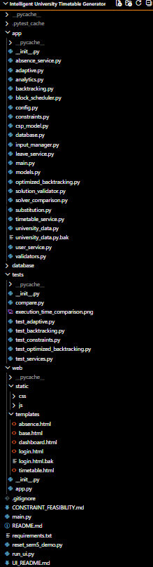
Figure B1

APPENDIX D – SCREENSHOTS

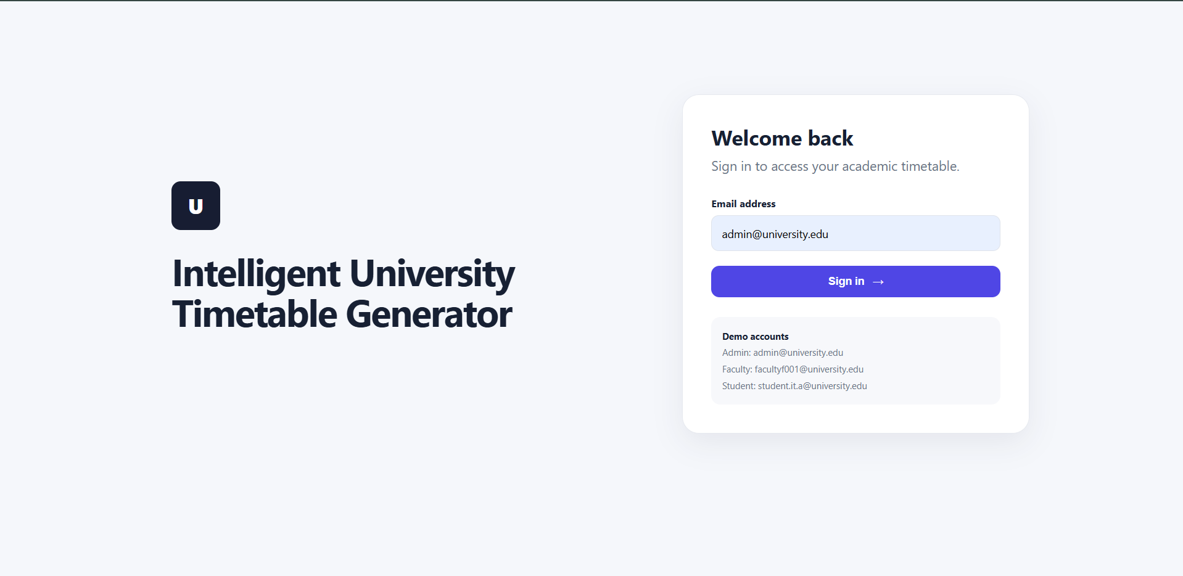
Figure D1 Login Page

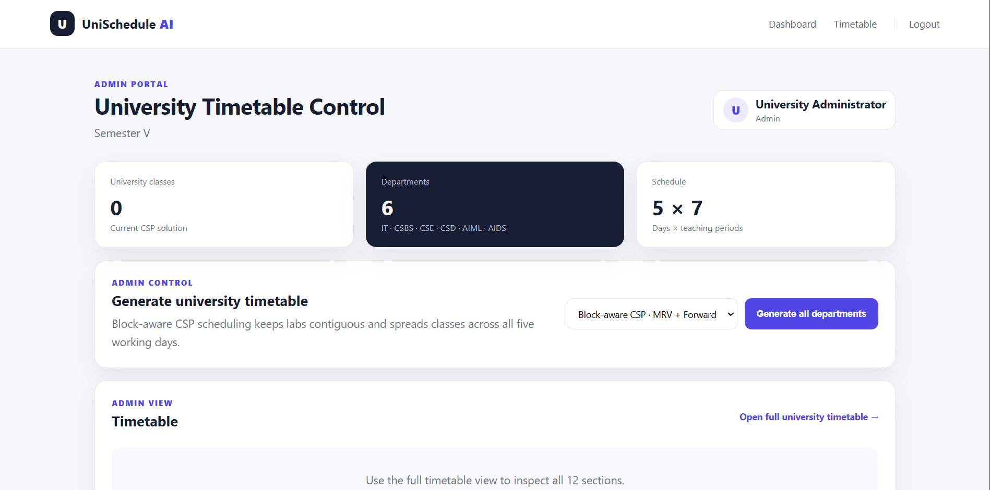
Figure D2 Admin Dashboard

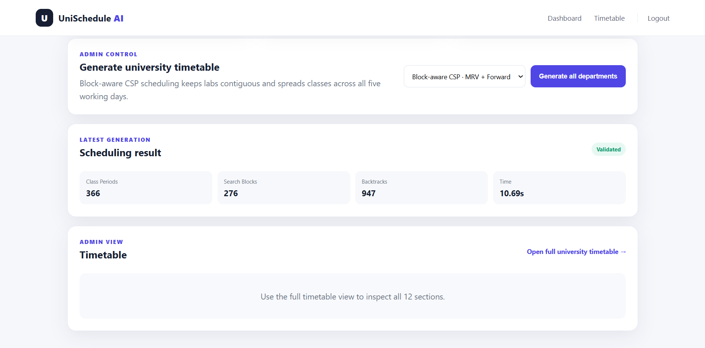
Figure D3 Timetable generated

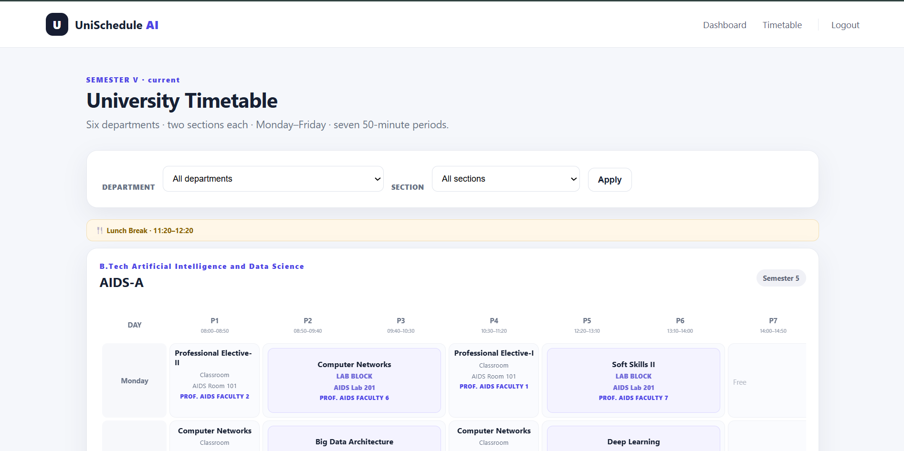
Figure D4 View All Timetables
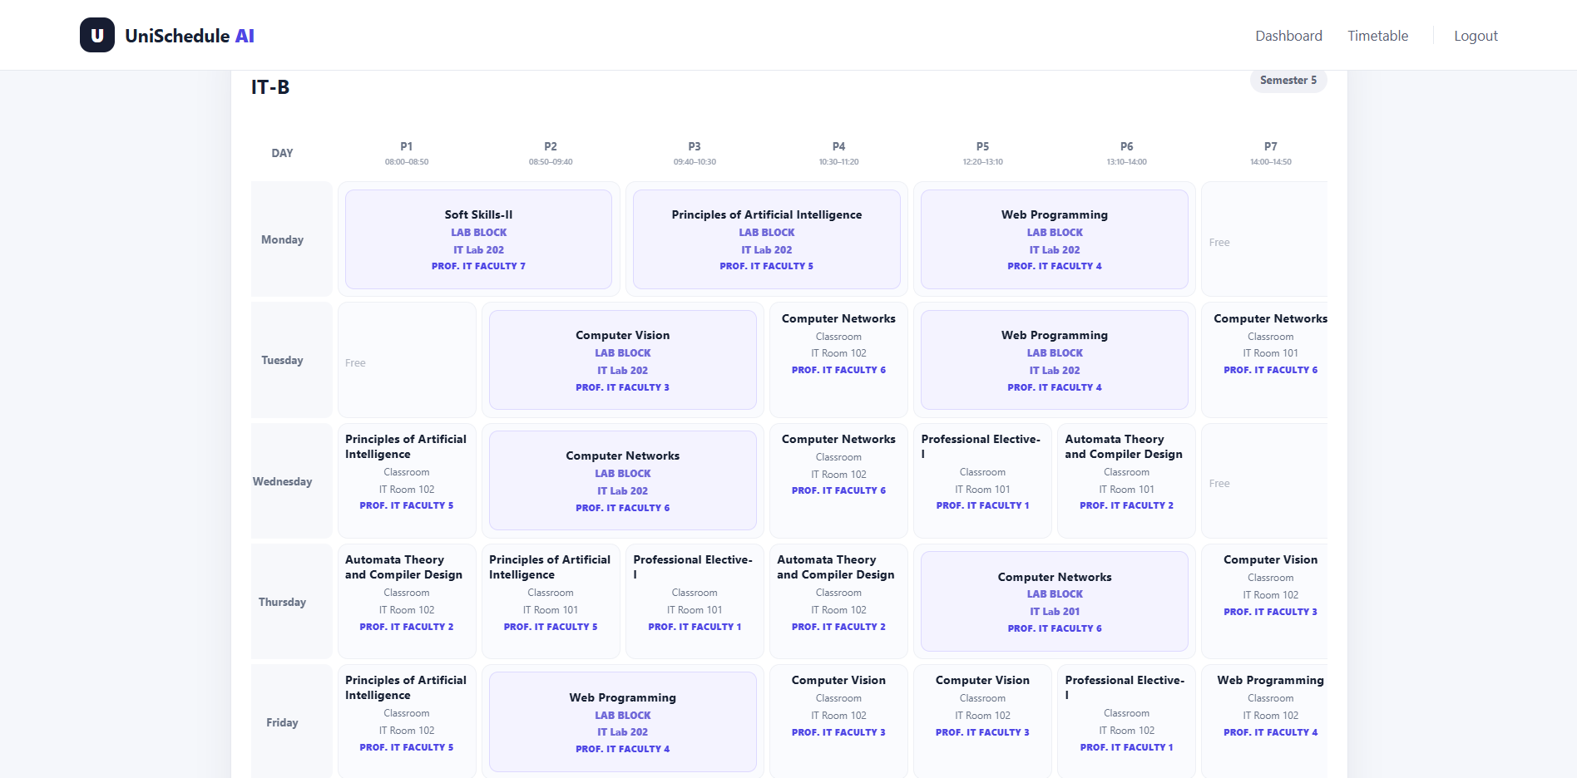
Figure D5 Timetable of IT-B

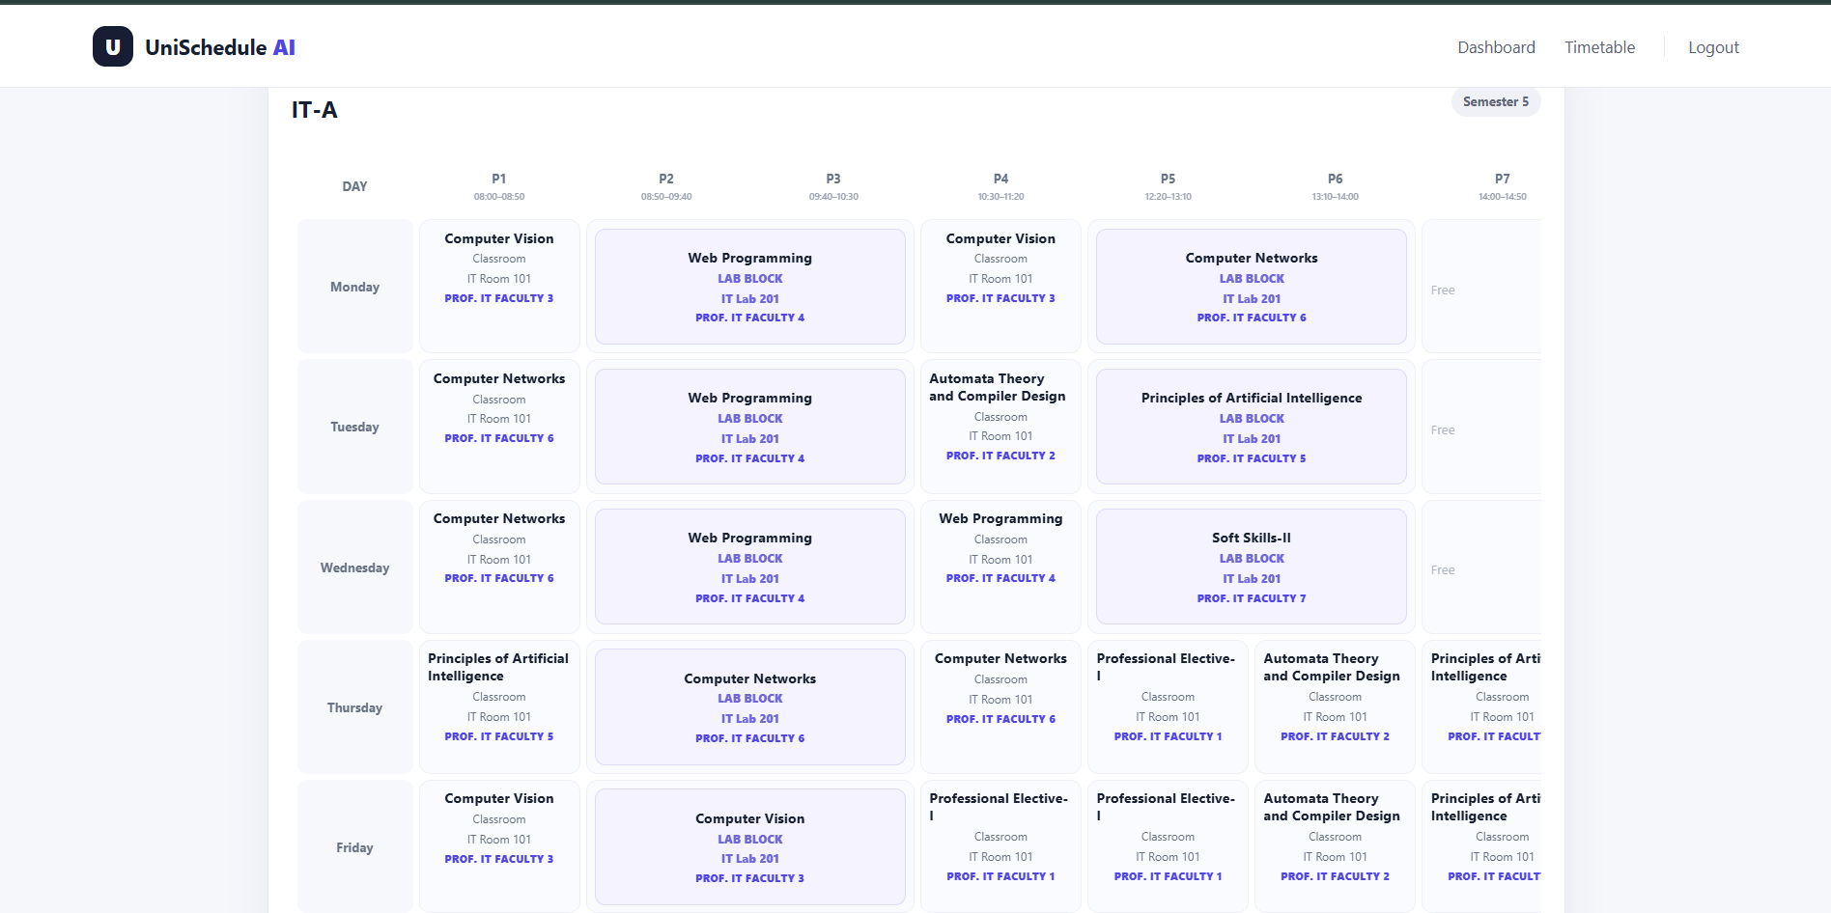
Figure D6 Timetable of IT-A

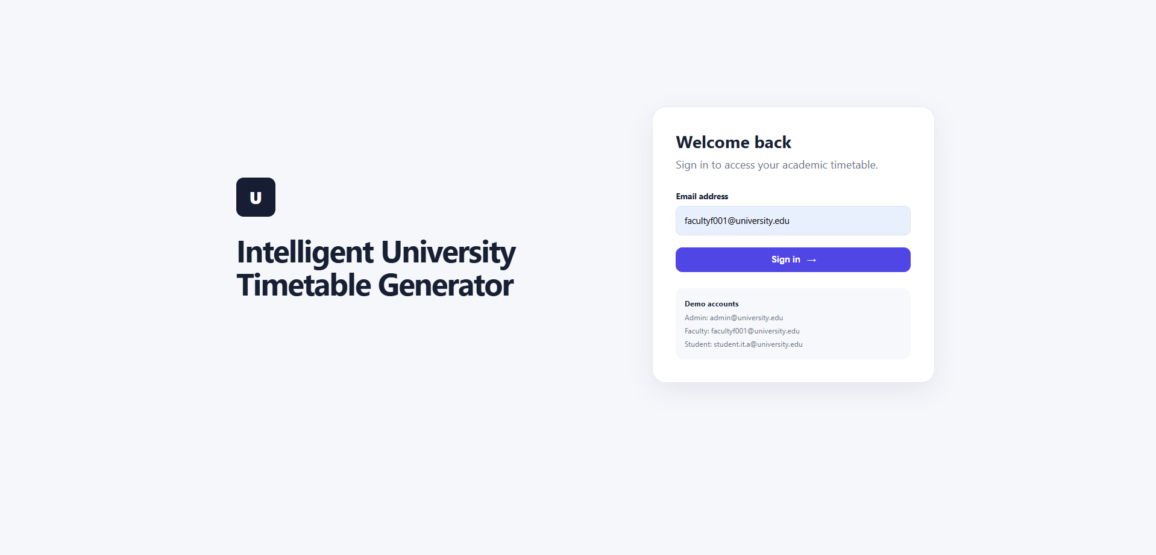
Figure D7 Faculty Login

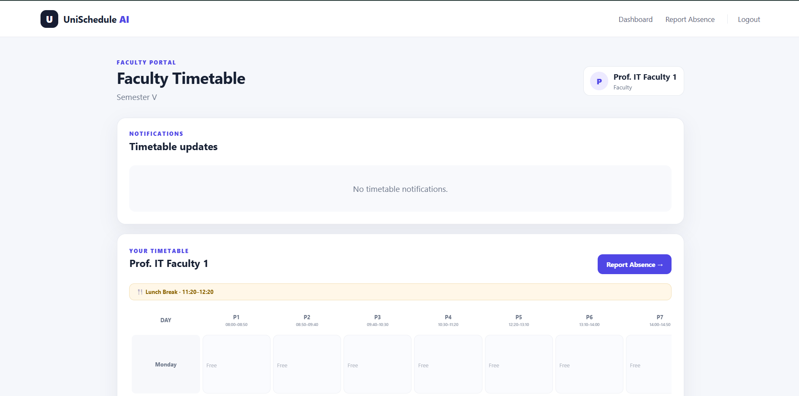
Figure D8 Faculty Dashboard
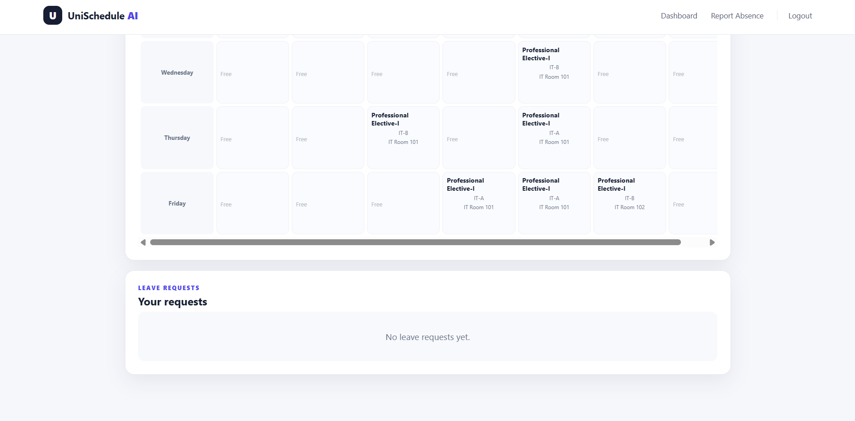
Figure D9 Faculty Leave Requests

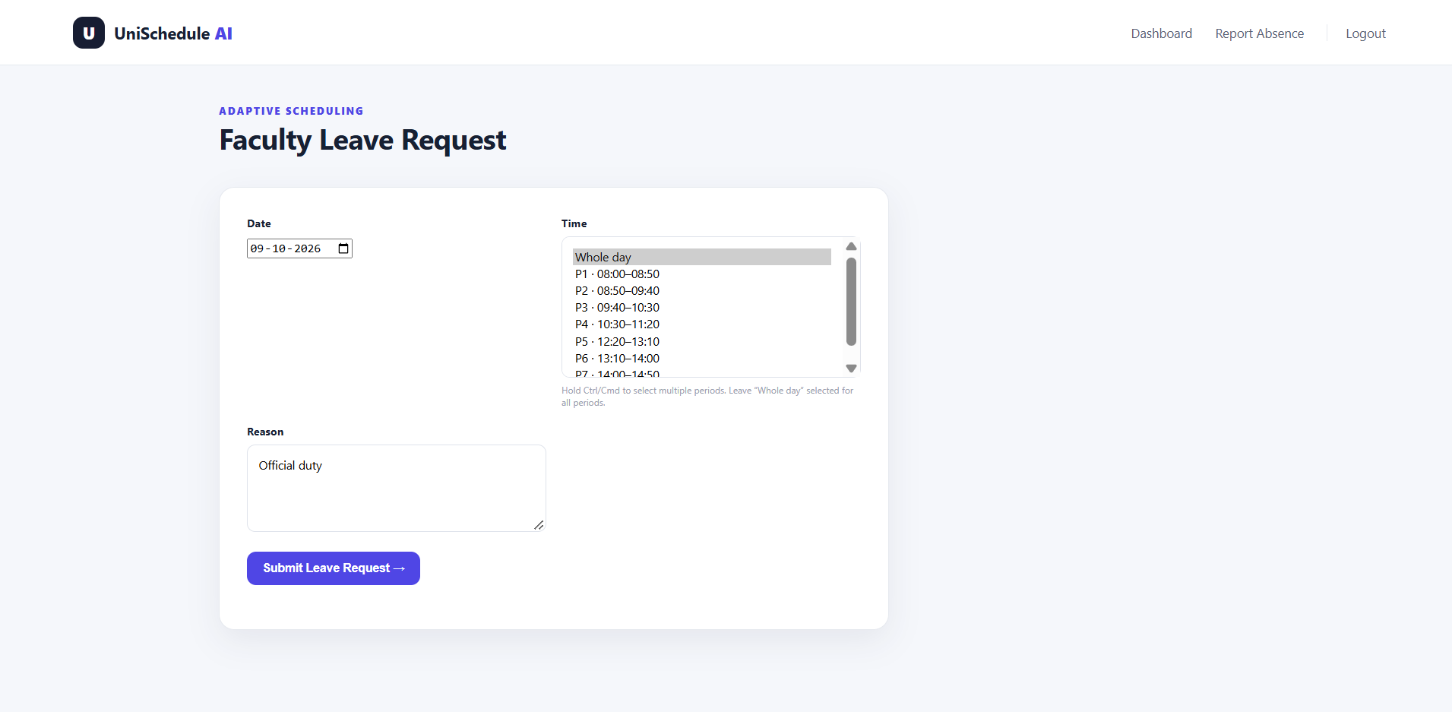
Figure D10 Faculty Report Absence
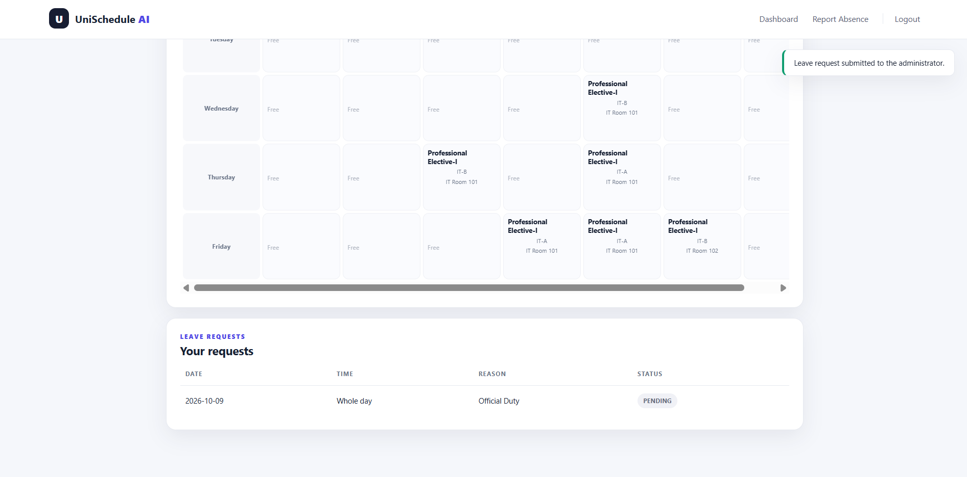
Figure D11 Updated Leave Requests (Pending)

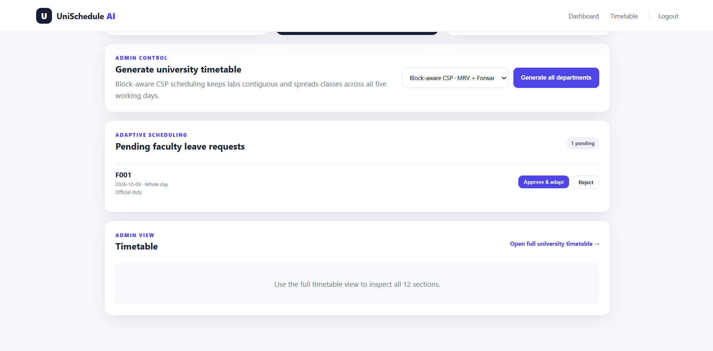
Figure D12 Leave Request in Admin Dashboard

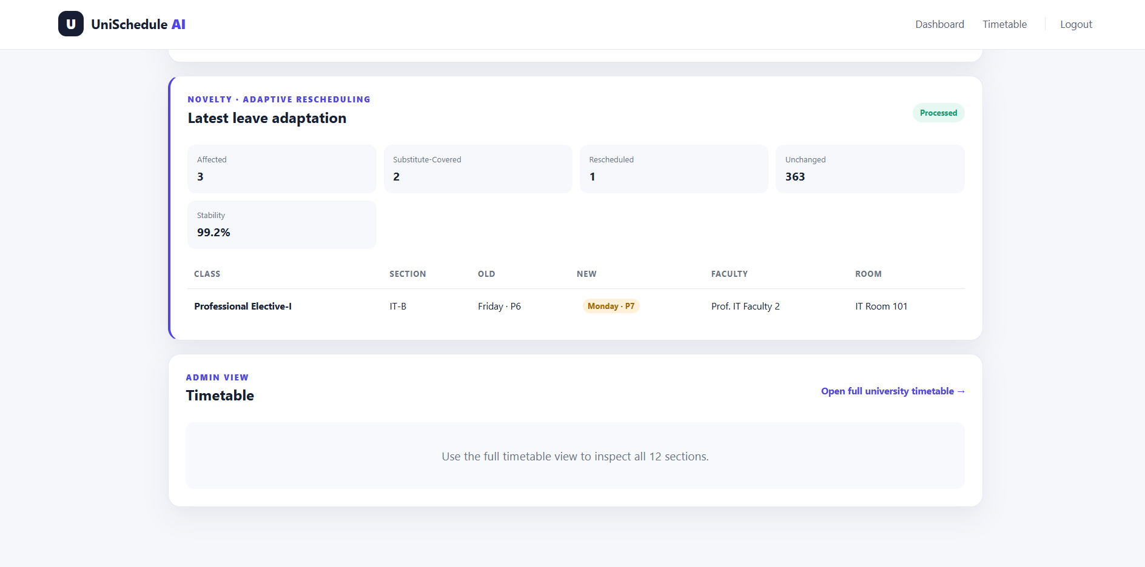
Figure D13 Result of approved leave request (Substituted & Rescheduled)

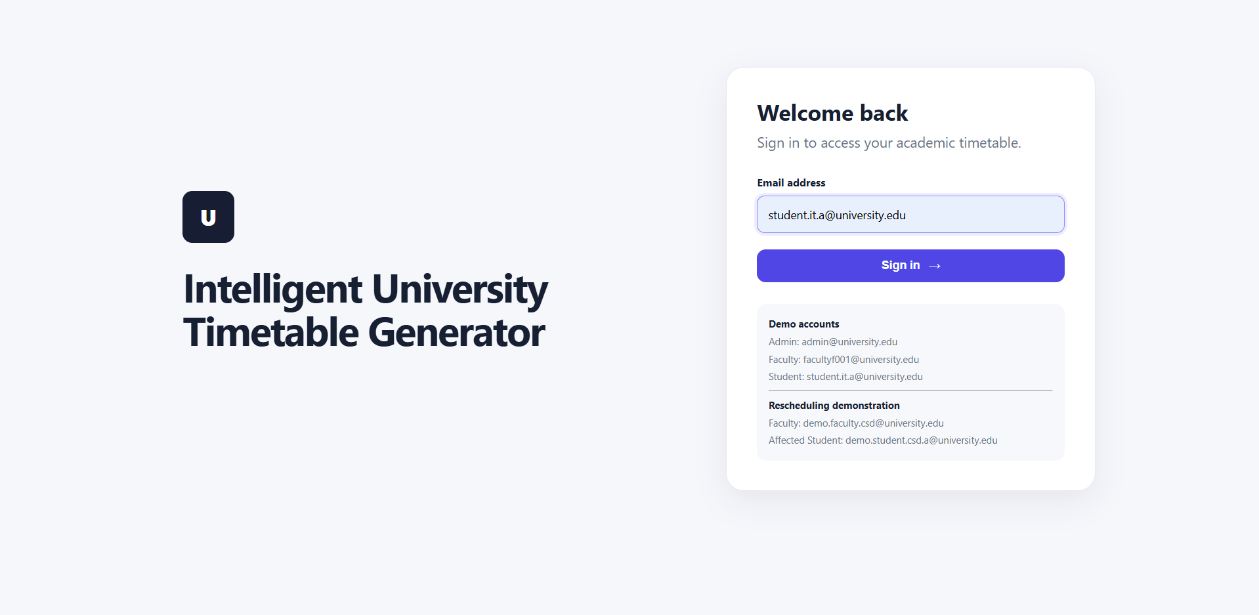
Figure D14 Student (IT-A) Login
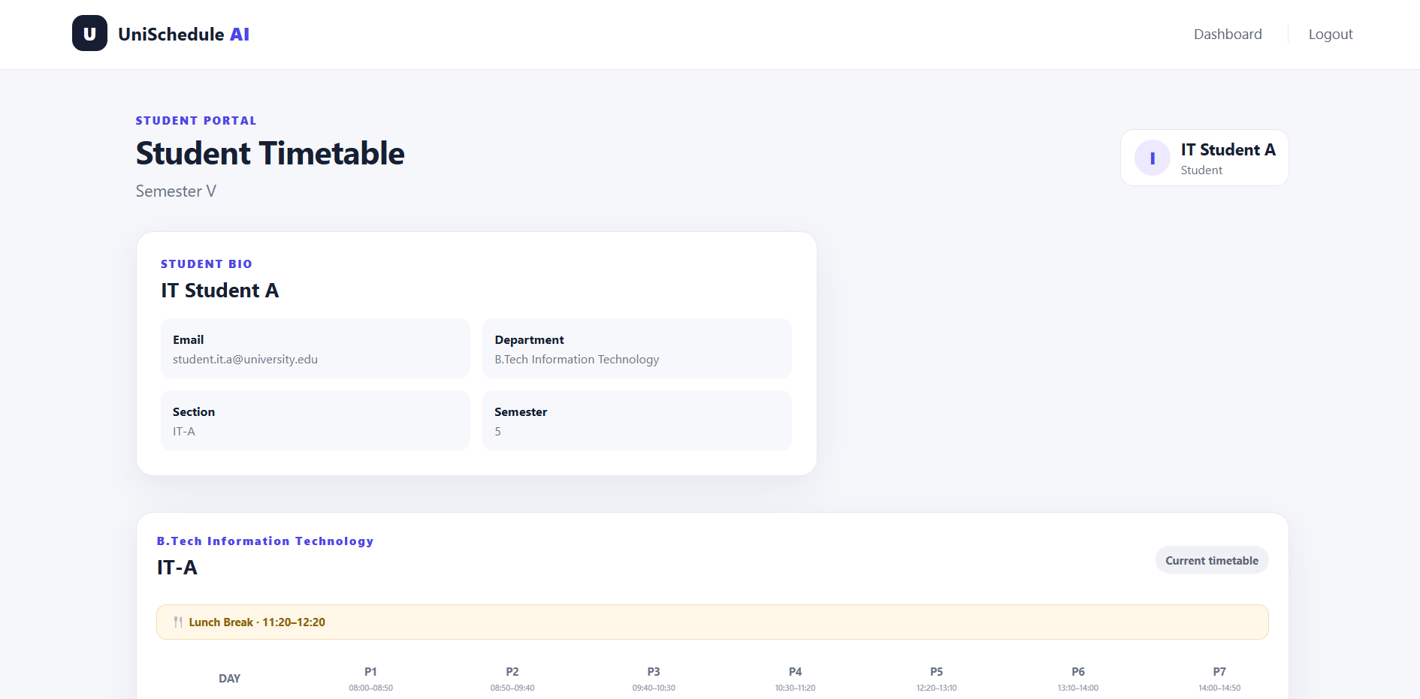
Figure D15 Student Dashboard

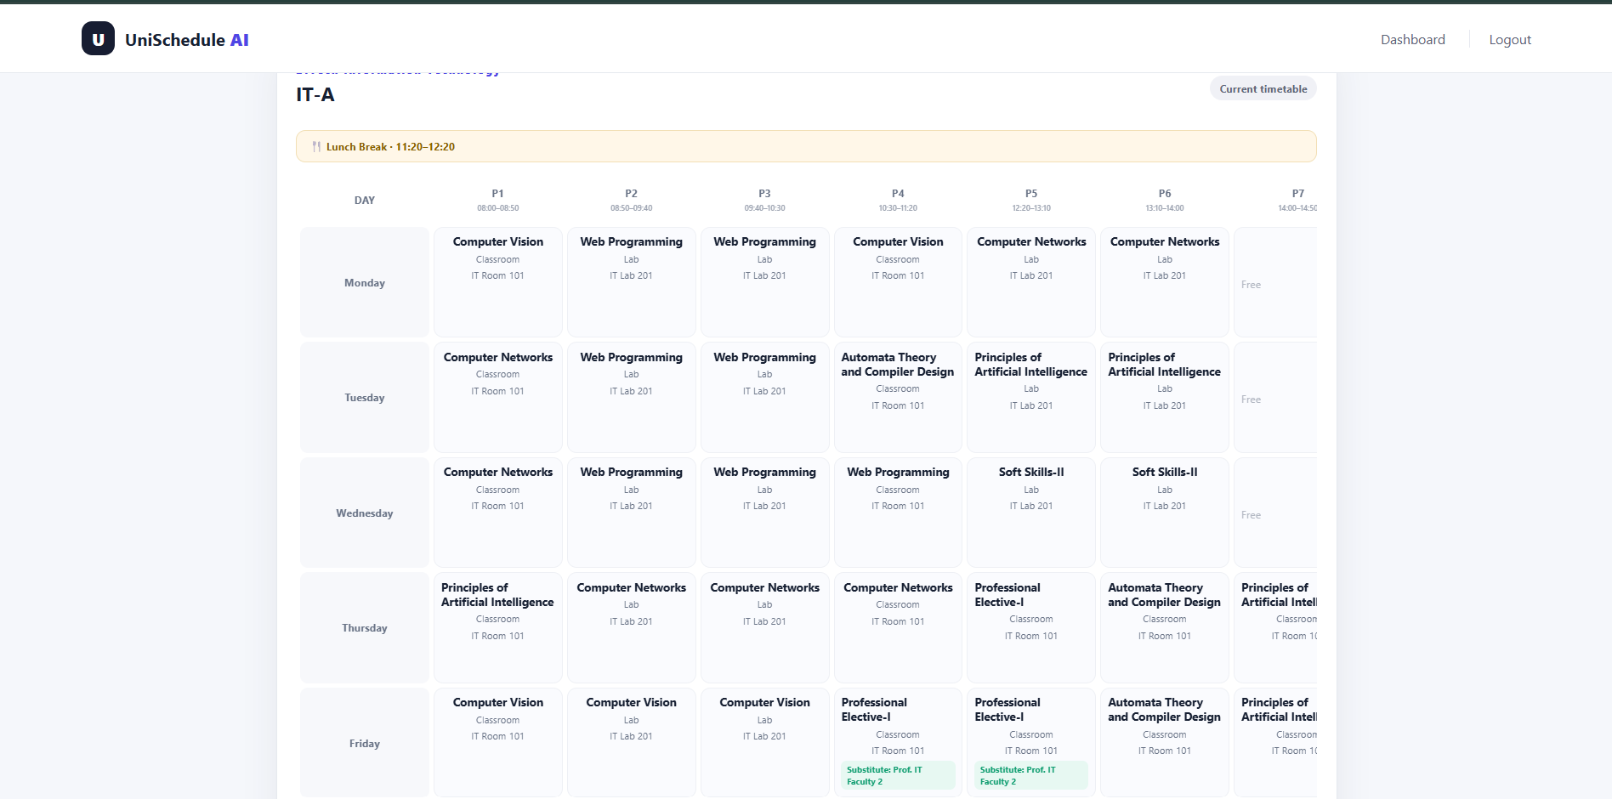
Figure D16 Student Timetable
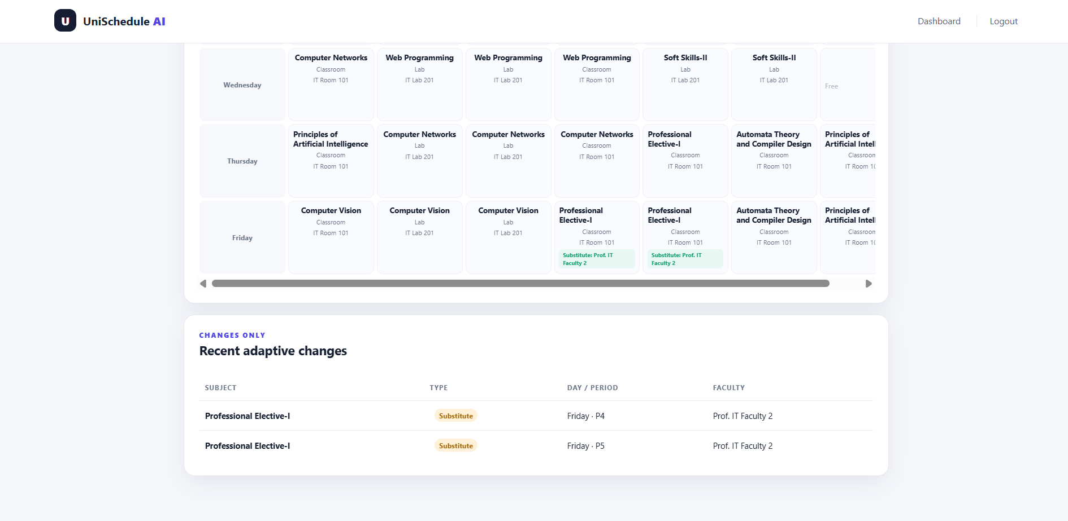
Figure D17 Changes in Student Timetable (IT-A) - Substitute

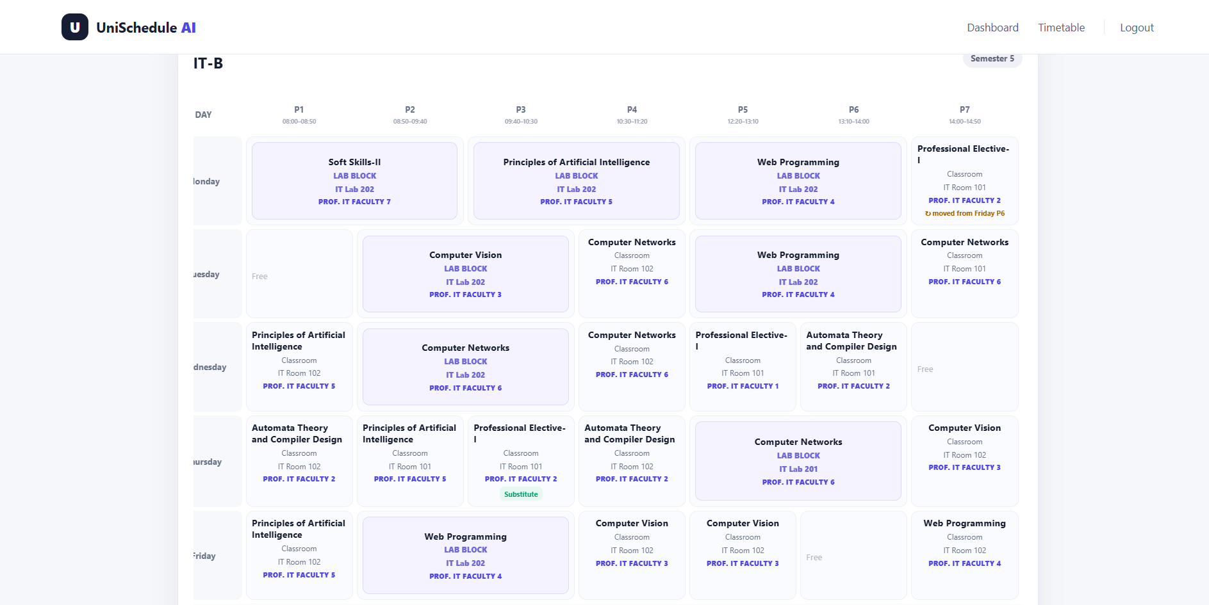
Figure D18 Changed Student Timetable (IT-B) - Rescheduled

